**Pinpad Quick Trouble Shooting Guide / Common Issues**

This is a list of common issues you may encounter (Stores calling in with problems or during the setup process.)

Issues during setup:

* **Device Offline Message**

**When attempting to pair the device In the back office on the register this message is displayed when pressing the register Verifone device button.**

* **COMM ERROR / Communication Error**

**This Error appears when the pinpad is rebooting after the IP configuration is set. This means that the pinpad can’t get a network connection. The IP settings must be reconfirmed that they were saved or entered correctly, and the cabling must be checked.**

**Possible resolutions/troubleshooting steps include:**

* **Checking the device IP configuration settings on the pinpad. If the status light on the config screen is RED it could be a possible connection or cabling issue. This can be confirmed as a cabling issue by checking the Meraki switch dashboard.**

* **Checking the Meraki Switch dashboard – This dashboard can determine the IP address that is being picked up on the network (if it doesn’t match what was set statically or was given on DHCP, reset IP config settings and check Xstore properties and run configs after stopping Xstore, restart Xstore.)**

* **The Meraki Dashboard can also be used to check line issues and run cable tests. If the light is blacked out for the pinpad port, have them verify the pinpad is powered on. If the pinpad is powered on, click the port icon and scroll down to trouble shooting. Run a cable test to determine if there is a line failure or a short. The distance from the Switch to the Cash registers varies from store to store but is usually 30 – 40 meters. If you have a line failure or short at 15m for example the short or failure is most likely in the cable run somewhere in the ceiling and a Wachter tech will need to be dispatched to re-run the line. (Send an email to PMretail to dispatch.)**

* **If the line failure or short is closer to the switch, or to the register, it may just be a patch cable (ethernet cord) that needs to be replaced. This can be confirmed by borrowing the cable from a working pinpad and swapping it into the one with issues or swapping the patch cable at the patch panel with the working port. (Depending on where the line problem is) Replacement cables can be ordered on TDX.**

* Text

  Description automatically generated**These errors may also appear if the Xstore properties were not saved, or the correct IP wasn’t entered. Also, if the configs were run while Xstore was still running. The IP address may not have been saved to the register. Verify the IP address in the Xstore properties, Stop Xstore, run the baseconfg.bat, then the config.bat, then start Xstore.bat. (MAKE SURE ONE IS COMPLETED BEFORE RUNNING THE NEXT) If they are ran out of order or at the same time it will not apply.**
* If the device was set to Static try setting it to DHCP mode and re-pairing. Sometimes the desired IP is already reserved by another device and can be interfering with the pairing process. It is always easiest to pair on DHCP. This allows the pinpad to select an IP that isn’t being used by another device and it can then be reserved on the DHCP list.
* **If a store calls in with their pinpads going offline intermittently (getting the DEVICE OFFLINE message when trying to complete transactions). Make sure to check the Meraki dashboard and see it the pinpad IP isn’t also being used by the mobile devices. If this happens set the pinpad to DHCP and re-pair with the register on the newly determined pinpad.**

* **DEPLOYMENT FAILURE – DEVICE LOCKED (On Pinpad screen)**

This error occurs when the pinpad is initially set up and is plugged in before the serial number is set up to the store hierarchy in Payware connect.

* To resolve this issue the pinpad serial number must be set up in PWC and then the “Device key removal Engage” bundle must be deployed via VHQ. Schedule > Downloads > Select device > next > Select bundle > next contact > save

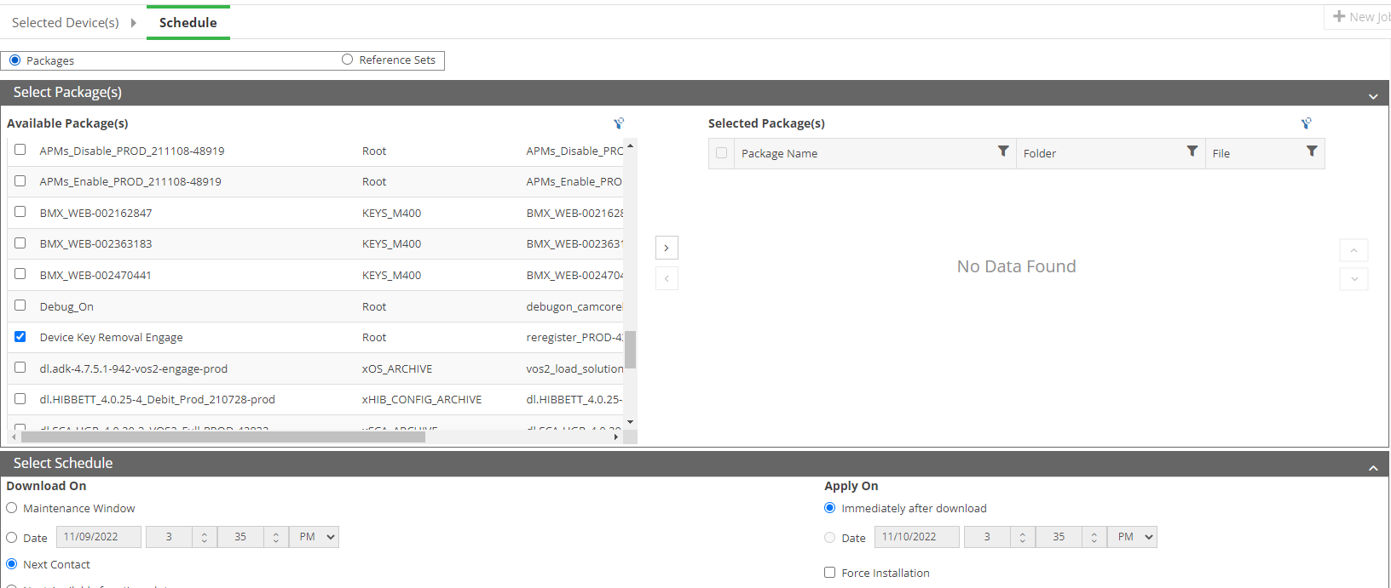

* **NOTE** – Right before deploying the bundle the reset button must be pressed in PWC. This download usually will take 5-10 minutes. The device will then reboot to the normal Hibbett or City Gear advertisements/ splash page.

* **Pinpad is showing “INACTIVE” in VHQ**

When the pinpad is initially set up or the store calls in complaining about digital payments not working.

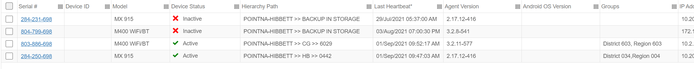

* First attempt to request a heartbeat on the pinpad to get the device to communicate with VHQ.
  + After entering in the Supervisor login go to the following:

***Administration -> VHQ Tools -> Request HB***

Select ***Status Info*** for the heartbeat results.

* If the HB request fails and the pinpad is online, paired, and is completing transactions normally, escalate to level II for further investigation.
* Also check the Key parameters in VHQ to make sure the device has been assigned a key by Verifone. **Detail > Security> Encryption Keys**. If there is no device key notify a Level II and order a replacement pinpad.

* **Digital Payment Issues**

Issues regarding Klarna or PayPal. (Timeout error on pinpad when paying with Klarna)

* First try clearing any “Stuck” transactions on the pinpad that is getting the error message. This can be done by having the SM hold 6 + the enter key on the pinpad the entering the PW (166831) to open the configuration menu. Then scroll down and press “Next” then press the “Launch CP App” button. Then select “Klarna” this will prompt them to enter the system PW again (166831) after this scroll down until you see option 10. “Clear Transaction” select this and clear sales. Then have them back out of the menu and re-attempt the sale. If the customer has already left a test can be performed by Scanning an item, selecting add tenders, digital payments, Klarna, pressing enter, and waiting for the QR code to appear on the pinpad. As long as the QR code appears then everything is working. The sale can then be canceled.

* If issues persist or a timeout error appears, check the Xstore properties files and make sure the correct “buffer reader timeout” parameter is set. If this setting needs to be updated. Save the parameter, stop Xstore, run the baseconfg.bat then the config.bat and restart Xstore and reattempt the test sale.

* If you are still getting the error on the pinpad, Check the VHQ configuration and downloaded bundles.
* Go to VHQ, find the device, select detail, and parameters, press edit on Klarna, and see if the MID and TID fields are filled out. If they are blank escalate to Level II so that they can be requested from Verifone.

* To check to see if the digital payment bundles are applied to the pinpad go to jobs and scroll over to the latest bundle and see if the Klarna, PayPal, and Venmo bundles are installed.
* If the bundles failed or aren’t installed, they can be redeployed by pressing Schedule, downloads, selecting the device, press next. Then select the following packages and press the arrow to move them over to the selected packages section and scroll down to the schedule section and select next contact and press submit. This download normally takes 15-30 mins.

* **Payment options Greyed Out – Device Not Authorized – Clearing Device keys Failing**
* If the payment options are greyed out on the register when trying to check out first check to see if the pinpad is paired to the register by logging into the back office and selecting the enable/disable hardware button and selecting the register Verifone device. If the device requests a pin number, then the pinpad is pared and we need to move to re-clearing the device keys. If the pinpad shows offline, follow the connection issue troubleshooting steps above.
* If the Register Shows the “device not authorized’ error when trying to complete the test sale. Try and repeat the key-clearing steps. Hold 6 +enter key >enter PW (166831) >Host registration Clear Keys. After that is successful, Select the encryption > Register.

* If the device fails during the clearing the keys step, attempt to click the reset button again on PWC and retry. If that fails, check DNS settings on the pinpad network config section they may be entered incorrectly. Pairing via DHCP would resolve this as well. Text

  Description automatically generated with medium confidence
* Hold 6 +enter key >enter PW (166831) >Host registration Clear Keys. After that is successful, Select the encryption > Register.

